A Route Towards High Efficiency Silicon Heterojunction Solar Cells
Weiyuan Duan*, Andreas Lambertz, Karsten Bittkau, Depeng Qiu, Kaifu Qiu and Kaining Ding
IEK-5 Photovoltaik, Forschungszentrum Jülich GmbH, 52428 Jülich, Germany
E-mail: w.duan@fz-juelich.de

Abstract
In this work, we propose a route to achieve a certified efficiency of up to 24.51% for silicon heterojunction (SHJ) solar cell on a full-size n-type M2 monocrystalline-silicon Cz wafer (total area, 244.53 cm²) by mainly improving the design of the hydrogenated intrinsic amorphous silicon (a-Si:H) on the rear side of the solar cell and the back reflector. A dense second intrinsic a-Si:H layer with an optimized thickness could improve the vertical carrier transport, resulting in an improved fill factor (FF). In order to reduce the plasmonic absorption at the back reflector, a low-refractive-index magnesium fluoride (MgF₂) is deposited before the Ag layer, this leads to an improved short circuit current density (J_{sc}). In total, together with MgF₂ double antireflection coating and other small optimizations during cell fabrication process, ~1% absolute efficiency enhancement is finally obtained. A detailed loss analysis based on Quokka3 simulation is presented to confirm the design principles, which also gives an outlook of how to improve the efficiency further.
Keywords
Silicon heterojunction solar cells, design, amorphous silicon, back reflector, loss analysis
- Introduction
The main objective of crystalline silicon photovoltaic (PV) technology development is to increase the power conversion efficiency and further reduce the production costs, aiming to reduce the levelized cost of electricity (LCOE). As one of the technologies with passivating contacts, silicon heterojunction (SHJ) solar cell technology is considered to expand its share in the PV industry in the coming years due to the high-power conversion efficiency, lean fabrication process and low temperature coefficient [1,2]. High efficiency is the biggest advantage of SHJ solar cells regarding to lower the LCOE. In recently years, milestones with certified SHJ solar cell efficiency of more than 24.5% have been reported by several organizations. For examples, Panasonic announced 24.7% conversion efficiency based on 98 μm thin wafers as early in 2013 [3]. Then in 2015, Kaneka reported the record efficiency of 25.1% with aperture area of 151.9 cm² by electrical copper plating [4]. In 2019 and 2020, Hanergy set two new world records in a row, reported full M2 area (244.5 cm²) efficiency of 24.85% and 25.1%, respectively [5-6]. This result once again brings to light the potential for heterojunction solar cell efficiency improvement. Recently, GS-Solar has announced that the conversion efficiency of its mass produced SHJ solar cells has reached 25.2%, which has been certified by TÜV Nord [7]. The very high fill factor (FF) of 85.82% makes it as the record for mass-produced SHJ solar cells on the market.
SHJ solar cells have an excellent open-circuit voltage (V_{oc}) of up to 750 mV [3] due to the superior silicon interface passivation provided by thin hydrogenated amorphous silicon (a-Si:H) layers, which has contributed significantly to the success of this architecture. However, the SHJ solar cells show a low short-circuit current density (J_{sc}) compared with the other two sides contacted crystalline silicon cells which is a result of the parasitic absorption due to the front a-Si:H layers and transparent conductive oxide (TCO) layer on both sides [8,9]. To improve J_{sc}, previous work mostly focused on developing more transparent window layers, such as replacing doped a-Si:H by hydrogenated nano-crystalline silicon oxide (nc-SiO_{x}:H) [10-12]. These approaches encountered challenges of how to achieve trade-off between optical and electrical properties [13,14] and industrial application issues like the process time [15]. Besides, even though high FF can be achieved among aforementioned champion efficiencies, there is still a gap to the reported theoretical FF of 88%-89% [16], which needs to be engineered further.
In this work, starting from a certified cell efficiency of 23.55% with V_{oc} of 741.2 mV, J_{sc} of 38.94 mA/cm² and FF of 81.85% measured in the certification lab CalTeC at Institute for Solar Energy Research in Hamelin (ISFH), a route towards higher efficiency SHJ solar cell is proposed through a combination of device simulation and experimental work. Comparing the certified result with the other high efficiency SHJ solar cells or theoretical values, it can be found that the difference in V_{oc} is minimal, however, the gap in J_{sc} and FF shows potential for significant improvement in efficiency. Performing a detailed power loss analysis (will be shown in Figure 7) of the cell revealed that reflection, light trapping and parasitic absorption dominate the current loss, and rear TCO/silicon vertical transport loss dominate the loss in FF. The method of looking for transparent thin films to reduce the parasitic absorption is always contradicting with reducing series resistance loss by implementing high conductive thin film layers. Thus, in this work an alternative route towards high efficiency (>24.5%) SHJ solar cells with rear emitter is rolled out. We have focused on the impact of rear side double intrinsic a-Si:H layers (basically no effect on cell optics) and an optimized metal back reflector together on the solar cell performance. An inclusive analysis during these developments is shown, together with a newly certified champion efficiency of 24.51% on a M2-size n-type crystalline wafer (total area, 244.53 cm²). Finally, the prospect to even high efficiency SHJ solar cell is also discussed.
- Experimental methods
During the study, all SHJ solar cells were fabricated using M2-size n-type Czochralski (CZ) crystalline silicon as-cut wafers from LONGi company, with resistivity of 1-5 Ωcm and a thickness of 180 μm. The wafers were firstly chemically etched to remove saw damage and then textured in alkaline solution to obtain random pyramids on both sides. After ozone cleaning finalized with a 1% diluted hydrofluoric acid solution, the wafers were transported into an AK 1000 plasma enhanced chemical vapor deposition (PECVD) tool from Meyer Burger for intrinsic and doped a-Si:H fabrication. Here, intrinsic a-Si:H bi-layers were used in the structure, the silane (SiH₄)/hydrogen (H₂) flow ratio and thickness were varied for the second layer of intrinsic a-Si:H bi-layers deposition, which will be discussed in details in the following content. Afterwards, 70 nm indium tin oxide (ITO) layers were sputtered from an 3% Sn-doped In₂O₃ target onto both sides of the wafers. Silver grids with a busbar-less design were screen printed on both sides of the ITO layers and subsequently cured at 170 ºC for 40 min. A very transparent MgF₂ layer with a thickness of 100 nm was sputtered on the top of the front ITO to act as a second antireflection coating layer. Part of the cells got a full area 200 nm evaporated Ag layer on the rear side, which acts together with ITO as a back reflector. For some of the other cells, a 70 nm MgF₂ layer was deposited before the Ag layer evaporation. The curing process for cells with MgF₂ was taken place after MgF₂ deposition instead of directly after screen printing, in order to fire the grids through the insulated MgF₂ layer. The structure of the final certified SHJ solar cell has a rear-emitter design as shown in Figure. 1.
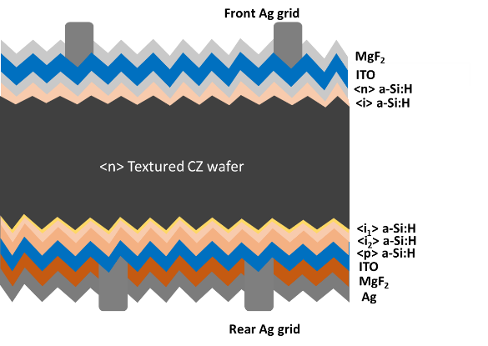
Figure. 1 Cross-sectional sketch of the certified SHJ solar cell
For material characterization, intrinsic a-Si:H films with thickness of 15 nm were deposited on polished float-zone crystalline silicon wafers. The thickness of the films was extracted from ellipsometer (J. A. Woollam M-2000) measurement. Structural characterization of the local bonding environments was performed by Fourier Transform Infrared Spectroscopy (FTIR) in a Nicolet 5700 system with wavenumber scanned from 400 cm⁻¹ to 4000 cm⁻¹. To evaluate the solar cells performance, current-voltage (J-V) characteristics were measured under standard test conditions (AM1.5, 25ºC and 100 mW/cm²) by the integrated solar cell characterization system called LOANA from pv-tools with a Wavelabs Sinus 220 light source. Furthermore, the external quantum efficiency (EQE) and reflectance (R) were measured on a 20 x 20 mm² area on the cells with grids inside.
- Results and discussion
3.1 Intrinsic a-Si:H bi-layers
The intrinsic a-Si:H layer plays multiple roles in SHJ solar cells not only as a surface passivation layer but also as a carrier transport channel to the electrode. In general, a high-quality intrinsic a-Si:H material with denser microstructure is beneficial for cell performance [17,18]. However, the direct growth of this type of material on the crystalline silicon surface can easily lead to epitaxial growth at the interface, which would be detrimental for surface passivation [19]. Intrinsic a-Si:H with a porous interfacial layer can improve the surface passivation by suppressing epitaxial crystallization, however it also causes an increase in series resistance [20]. To balance passivation and charge carrier transport, intrinsic a-Si:H bi-layers with a porous first layer and a dense second layer are a viable route. Beside the microstructure of intrinsic a-Si:H, its thickness also plays an important role in solar cell performance due to the low conductivity. The optimum thickness of intrinsic a-Si:H would result in sufficient passivation without excessive series resistance loss. Based on these design principles, intrinsic a-Si:H bi-layers were used in our SHJ solar cell structure, and the microstructure and thickness of the second intrinsic a-Si:H (i₂), used on the rear side of the cells, were specially optimized here to reduce the vertical charge carrier transport loss.
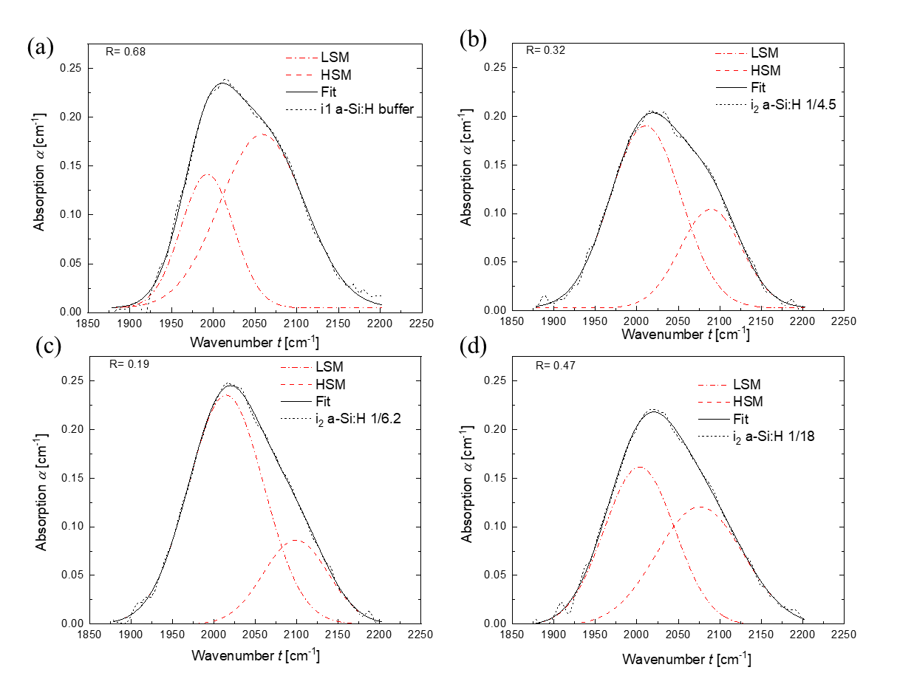
Figure 2. Absorption coefficient spectra obtained by FTIR for (a) the first intrinsic a-Si:H (i₁) layer and (b), (c), (d) the second intrinsic a-Si:H (i₂) layers with a variation of SiH₄/H₂ flow ratio, fitted with two Gaussian-distributed absorption peaks centered at wavenumbers of 2000 cm⁻¹ for low-stretching mode (LSM) and 2100 cm⁻¹ for high-stretching mode (HSM). R is the microstructure factor which is defined as the peak intensity of HSM divided by the sum of peak intensity of HSM and LSM.

To investigate the microstructure of the intrinsic a-Si:H thin films, the absorption coefficient spectra versus wavelength of a-Si:H films obtained by FTIR spectroscopy is shown in Figure 2. Among them, Figure 2(a) and 2(b) show the results of the first intrinsic a-Si:H (i₁) layer and the originally used i₂ layer, respectively. Then the SiH₄/H₂ flow ratio for i₂ layer has been decreased, resulting in a different microstructure as shown in Figures 2(c) and (d). Curve fitting using Gaussian functions has been performed to determine the strength of the low-stretching mode (LSM) and the high-stretching mode (HSM) centered at wavenumbers of around 2000 cm⁻¹ and 2100 cm⁻¹, respectively [21]. The LSM represents the vibration of compact hydrogen (monohydrides) incorporation, while the HSM is attributed to the vibrations of hydrogen clusters (dihydrides, trihydrides) grouped together at the surfaces of nano-sized voids [22-24]. The microstructure factor R is defined as R= I_{HSM}/(I_{LSM}+I_{HSM}), where I_{LSM} and I_{HSM} are absorption peak intensities of the low- and high-stretching modes [25]. In this definition, the larger R means the higher the density of nano-sized voids in the a-Si:H films. Figure 2 shows R of 0.68 for i₁ layer and 0.32 for the original i₂ layer. The large R of i₁ layer reveals a porous intrinsic a-Si:H layer used on the crystalline silicon surface. Slightly decreasing the SiH₄/H₂ ratio to 1/6.2 for i₂ layer significantly decreased the R from 0.32 to 0.19. This is mainly due to the etching effect from more hydrogen plasma, which breaks up weak Si-bonded hydrogen in the formation of clusters, making the film denser. Further decreasing the SiH₄/H₂ ratio will again increase the void density in the film (larger R). This may be caused by a partial crystallization of the film due to too much hydrogen dilution, which needs further investigation later.
The effect of i₂ layer with different SiH₄/H₂ flow ratio and thickness on SHJ solar cell performances were verified by six bifacial cells without a second antireflection coating layer for each group, and the J-V parameters in (a) V_{oc}, (b) J_{sc}, (c) FF and (d) the conversion efficiency were summarized as shown in Figure 3. Firstly, the original thickness of i₂ layer (d_{i2}) was fixed at 7 nm. The V_{oc} of the cells remained constant within the statistical fluctuation when varying the SiH₄/H₂ flow ratio, which indicated a similar passivation despite of the microstructure factor variation. Similar to V_{oc}, the J_{sc} also showed almost no difference by changing the R of i₂ layer on the rear side of the cells. More clearly, significantly increased FF was obtained when decreasing the SiH₄/H₂ ratio from 1/4.5 to 1/6.2 with R reduced from 0.32 to 0.19, which was related to the enhanced charge carrier transport due to high-quality i₂ layer with lower defect density (smaller R). This was also confirmed by reduced whole vertical contact resistance from 350 to 180 mΩ.cm² measured by Transfer Length Method [26], among which the contact resistance between ITO/a-Si:H accounted for the largest part. Further decreasing of SiH₄/H₂ ratio resulted slightly lower average FF due to the increased R as described in Figure 2. As a consequence, i₂ layer with the smallest R showed the highest conversion efficiency. Based on this, the thickness of i₂ layer was further optimized. By reducing the thickness from 7 nm to 5.6 nm, slightly higher averaged FF value with less deviation was obtained, and passivation was maintained as the averaged V_{oc} value was still above 735 mV. However, the passivation was destroyed by further decreasing the i₂ layer thickness to 4.6 nm, resulting in a deterioration in V_{oc}, J_{sc} and FF. Finally, the conversion efficiency of SHJ solar cells increased from 23.35% to 23.70% on average by optimizing the i₂ layer.

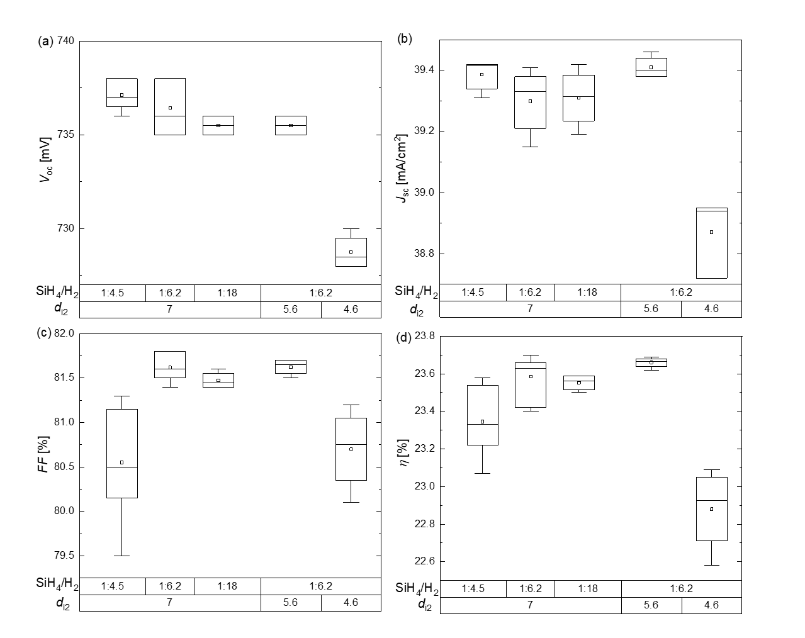
Figure 3. J-V parameters: (a) J_{sc}, (b) V_{oc}, (c) FF and (d) conversion efficiency of SHJ solar cells fabricated as a function of SiH₄/H₂ flow ratio and thickness of the i₂ layer (d_{i2}).

3.2 Back reflector
Crystalline silicon solar cells have poor conversion for wavelengths near the active-layer bandgap, motivating light management studies in the infrared range [27]. Especially for SHJ solar cells which require TCO layers at the front and rear to transport charge carriers laterally, free charge carriers in these layers absorb infrared light which can hardly contribute to the current generation of the solar cell. The infrared light management for bifacial SHJ solar cells includes reducing the parasitic absorption and minimizing the potion of escaped light as well. There is always a limit in developing more transparent thin film layers, since a tradeoff between optical and electrical performance has to be considered, as more transparent layers often result in lower conductivities [28]. Thus, to increase the optical pathlength by reducing the escaped light in the infrared region seems to be a more independent way to increase current generation. In SHJ solar cells, full area Ag after TCO layer typically acts as a back reflector and contact. However, plasmonic absorption at the rough TCO/metal interface induced by light scattering of evanescent waves has been reported [29, 30], making the effect of back reflection much less effective. In cells like passivated emitter with rear locally diffused (PERL) cells, the silicon nitride, silicon dioxide or aluminum oxide rear passivation layer simultaneously enhances reflectance since these dielectric layers can limit the cone of light that is transmitted to the lossy metal electrode [31-33]. From a purely optical perspective, the best rear dielectric layer for solar cells with micrometer-sized or larger rear textures should have the lowest possible refractive index [34]. Campbell et. al. hypothesized excellent internal reflectance by inserting a layer of low-refractive-index MgF₂ between the rear passivation layer and aluminum rear electrode in PERL-like cells [35]. Here, 70 nm MgF₂ was introduced before 200 nm Ag back reflector evaporated on the bifacial cells. During cell fabrication, the curing process for rear printed fingers was done after MgF₂ evaporation in order to fire the fingers through the insulated material and make a reliable contact to following layer. For comparison, SHJ solar cells with only 200 nm Ag layer were also prepared, the relative change of cell performance to standard bifacial reference cell is shown in Figure 4. It’s necessary to mention that the cells here already had MgF₂ double antireflection coating on the front. As revealed by the results, there was no compromise for FF when introducing either of the two back reflectors, which demonstrates that no extra resistive loss was induced by inserting an insulated layer before the full area Ag. The slightly higher V_{oc} for cells with rear MgF₂ might be related to the extra annealing during the film evaporation process. The maximum absolute increase of J_{sc} was 0.45 mA/cm² for cells with only Ag back reflector. A higher gain of 0.63mA/cm² was achieved after introducing the thin MgF₂ layer before Ag. Overall, the efficiency improvement mainly came from the J_{sc} gain. Cells with MgF₂/Ag back reflector could increase the efficiency by 2%, which is a very attractive method of further gaining cell efficiency for monofacial application cases.

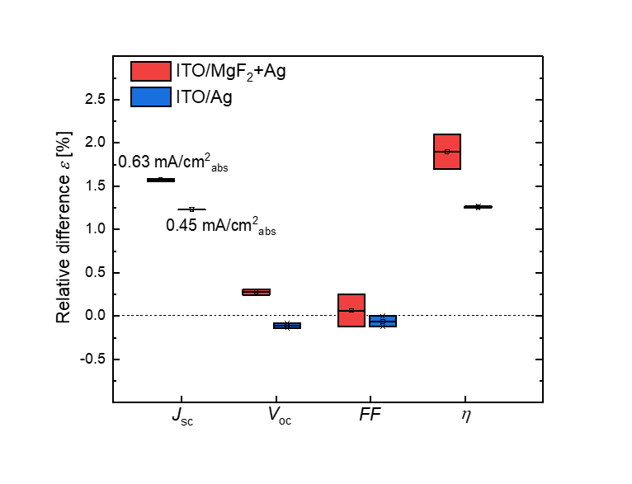
Figure 4. Relative difference of solar cell parameters after introducing ITO/Ag (blue symbols) or ITO/MgF₂+Ag (red symbols) back reflectors compared to cells with no back reflector.

Figure 5 shows EQE and 1-R spectra before and after Ag and MgF₂/Ag preparation, respectively, to figure out how different back reflectors affect light management. By comparing the solid lines before preparation of back reflectors and the dashed lines with reflectors, the main differences came from the infrared region, where EQE and the escaped reflectance all increased. After introducing Ag or MgF₂/Ag layers, ITO together with the layers acted as back reflectors. The transmittance loss was transferred to the increased internal reflection and parasitic absorption (including parasitic absorption in layers and plasmonic absorption) in the back reflectors. Even though higher internal reflectance would cause higher escaped reflectance, still part of the photos had been successfully absorbed by silicon bulk and transferred to charge carrier generation as EQE all improved, which was the source of J_{sc} enhancement. After introducing a 70 nm MgF₂ between the rear ITO and Ag layer, the escaped reflectance increased further as shown by comparing the red and black dashed lines. This was mainly due to the increased internal reflectance by reducing the plasmonic absorption on the Ag surface with this low-refractive-index dielectric material. As the difference between the EQE and 1-R accounts for the parasitic loss as well as from transmission loss, with back reflectors, transmission loss decreased to zero, so this area mainly represented the total parasitic absorption in the back reflectors [36]. This also confirmed a reduced plasmonic absorption with adding this 70 nm MgF₂ before Ag evaporation. As shown from the black and red dashed lines, the total parasitic absorption decreased after inserting MgF₂ layer with both superior EQE and escaped reflectance, which means part of the reduced plasmonic absorption had been transferred to charge carrier generation which contributed to the further increase in J_{sc}.

Figure 5. External quantum efficiency and 1-Reflectance of SHJ solar cells before (solid) and after (dashed) different back reflector preparation. The black lines represent cells with and without Ag reflector, and the red lines represent cells with and without MgF₂ + Ag reflector.

3.3 Power loss analysis
Based on the aforementioned optimization, by combining with other fine-tuning steps, such as environment control, proper wafer handling and a long term 1 sun light curing (slightly reduces the saturation current density J_{o2}), eventually we have brought the certified SHJ solar cell efficiency from 23.55% (with I_{sc} of 9519 mA, V_{oc} of 741.2 mV and FF of 81.58%) to 24.51% on total area of 244.5 cm² measured at ISFH. This cell has I_{sc} of 9663 mA, V_{oc} of 741.8 mV and FF of 83.61% as shown in Figure 6.
A detailed loss analysis for these two certified cells has been conducted by using Quokka3 simulation tool [37]. The measured EQE and layer properties of the thin films were considered to properly describe front layer transmission losses and light-trapping parameters in Quokka3. Figure 7(a) and 7(b) shows the current and free energy losses for the old and newly certified full-size cells with busbar less design. Figure 7(a) reveals that the main optical loss aroused from external reflection and parasitic absorption for the 23.55% cell, which has been significantly reduced by applying the MgF₂ double antireflection coating layer on the newly certified 24.51% cell. The transmission loss at the back reflector or light that is reflected at the rear side and escaping at the front contributed to the “light trapping loss”. In the cell with MgF₂ double antireflection coating and optimized back reflector, this loss was very similar to the original bifacial cell as shown in Figure 7(a). The reason was that there were two effects, reduction of transmission loss and reduction of reflection loss at the front coming together for the newly certified cell. The reduction of transmission loss would reduce the light trapping loss; however, the reduction of reflection loss would increase the amount of light which couples into the cell, therefore also scaled up the generated current. Even though the “light trapping loss” had a similar absolute value for these two cells, the ratio between the loss and whole generated current was actually decreased for the newly certified cell due to reduced optical loss by putting the back reflector. The main electrical loss relating to the rear TCO/a-Si:H contact resistance was dramatically reduced for the newly certified cell as shown in Figure 7(b), owing to the optimized i₂ layer on the rear side, which was consistent with the aforementioned material and device results in Figure 2 and Figure 3. In addition, slightly better passivation was also found, attributed to a more stable and clean process. To further improve the solar cell efficiency, based on the optical analysis, more efforts need to be made to reduce the parasitic absorption, such as replacing the doped a-Si:H layer with a more transparent nc-SiO_{x}:H layer. From electrical point of view, except using higher wafer quality, optimization of the front TCO layer may give slightly higher chance to increase efficiency quickly. This can be realized by using multiple TCO layers to simultaneously meet both optical and electrical requirements.

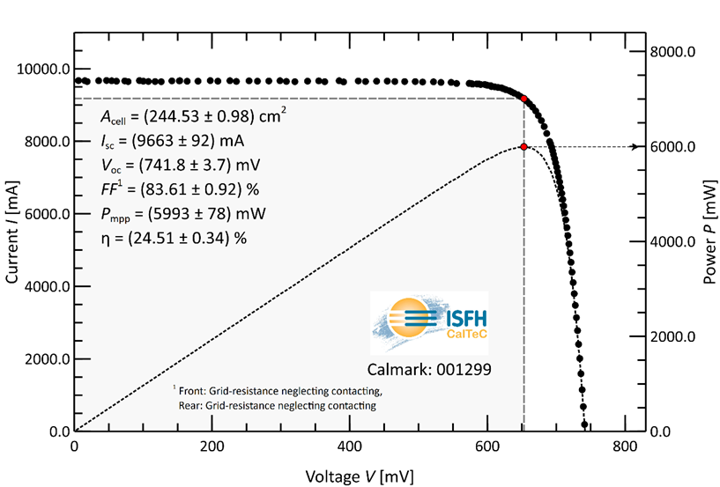
Figure 6. I-V characteristics of the 24.51% efficiency SHJ solar cell certified by ISFH CalTeC

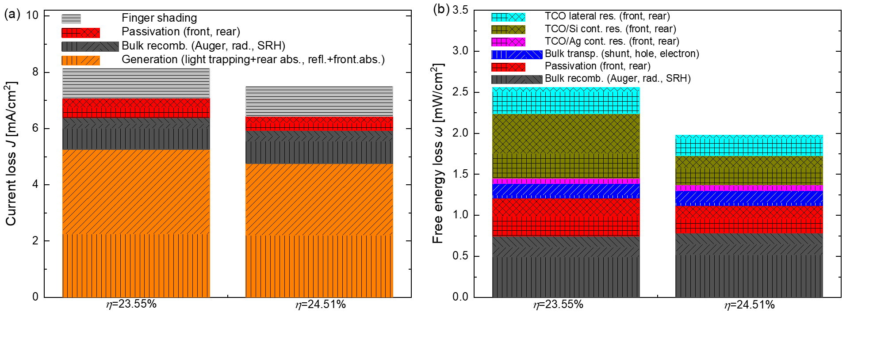
Figure 7. (a) Current and (b) Free energy loss analysis for old and newly certified SHJ solar cells based on Quokka3 simulation.
- Conclusions
In this paper, we demonstrated a route towards high efficiency SHJ solar cells. By using a denser and thinner second part of the intrinsic a-Si:H layer, a reduced vertical rear resistance loss was achieved. This favored vertical carrier transport and led to a higher FF. It was also shown that by inserting a thin MgF₂ before Ag back reflector preparation, one could obtain a higher J_{sc} gain due to the reduced plasmonic absorption. Finally, we were able to improve the efficiency from certified 23.55% to 24.51% on a total M2 area, mainly driven by FF and J_{sc} improvement. A detailed loss analysis based on the Quokka3 simulation confirmed the design principles and also gave us some insights on how to further improve the cell efficiency.

Acknowledgements: The authors gratefully acknowledge the funding of the German Federal Ministry of Economic Affairs and Energy in the framework of the STREET project (grant: 0324275E), TUKAN project (grant: 0324198D) and TOUCH project (grant: 0324351). The authors also want to thank the HEMF (Helmholtz Energy Materials Foundry) infrastructure funded by the (HGF) Helmholtz association and LONGi company for wafer supply.
References:
[1] Y. Liu, Y. Li, Y. Wu, G. Yang, L. Mazzarella, P. Procel-Moya, A. C. Tamboli, K. Weber, M. Boccard, O. Isabella, X. Yang, B. Sun, High-Efficiency Silicon Heterojunction Solar Cells, Mater. Sci. Engineering R 142(2020)100579.
[2] S. D. Wolf, A. Descoeudres, Z. C. Holman, C. Ballif, High-efficiency silicon heterojunction solar cells: a review, Greenpeace 2(2012)7-24.
[3] M. Taguchi, A. Yano, S. Tohoda, K. Matsuyama, Y. Nakamura, T. Nishiwaki, K. Fujita, E. Maruyama, 24.7% record efficiency hit solar cell on thin silicon wafer, IEEE J. Photovoltaics 4(2014)96-99.
[4] D. Adachi, J.L. Hernandez, K. Yamamoto, Impact of carrier recombination on fill factor for large area heterojunction crystalline silicon solar cell with 25.1% efficiency, Appl. Phys. Lett. 107(2015)233506.
[5] Hanergy sets new efficiency record for heterojunction cell, https://www.pv-magazi ne.com/2019/08/08/hanergy-sets-new-efficiency-record-for-heterojunction-mo dule/.
[6] X. Ru, M. Qu, J. Wang, T. Ruan, M. Yang, F. Peng, W. Long, K. Zheng, H. Yan, X. Xu, 25.11% efficiency silicon heterojunction solar cell with low deposition rate intrinsic amorphous silicon buffer layers, Solar Energy Mater. Sol. Cells 215(2020)110643.
[7] GS-Solar’s mass produced HJT cell achieves conversion efficiency of 25.2%.
http://www.pvtime.org/gs-solars-mass-produced-hjt-cell-achieves-conversion-efficiency-of-25-2/.
[8] Z. C. Holman, A. Decoeudres, L. Barraud, F. Fernandez, J. Seif, S. De Wolf, C. Ballif, Current loss at the front of silicon heterojunction solar cells, IEEE J. Photovolt. 2(2012)7-15.
[9] M. Green, E. Dunlop, J. Ebinger, M. Yoshita, N. Kopidakis, A. Ho-Baillie, Solar cell efficiency tales (Version 55), Prog. Photovolt Res Appl. 2020, 28, 3.
[10] D. Qiu, W. Duan, A. Lambertz, K. Bittkau, P. Steuter, Y. Liu, A. Gad, M. Pomaska U. Rau, K. Ding, Front contact optimization for rear-emitter SHJ solar cells with ultra-thin n-type nanocrystalline silicon oxide, Solar Energy Mater. Sol. Cells 209(2020)110471.
[11] L. Mazzarella, A. B. Morales-Vilches, L. Korte, R. Schlatmann, B. Stannowski, Ultrathin nanocrystalline n-type silicon oxide front contact layers for rear-emitter silicon heterojunction solar cells, Sol. Energy Mater. Sol. Cells 179(2018)386–391.
[12] V. Smirnov, A. Lambertz, S. Moll, M. Bär, D. E. Starr, R. G. Wilks, M. Gorgoi, A. Heidt, M. Luysberg, B. Holländer, F. Finger, Doped microcrystalline silicon oxide alloys for silicon-based photovoltaics: optoelectronic properties, chemical composition, and structure studied by advanced characterization techniques, Phys. Status Solidi 213(2016)1814–1820.
[13] L. Mazzarella, S. Kirner, O. Gabriel, S. S. Schmidt, L. Korte, B. Stannowski, B. Rech, R. Schlatmann, Nanocrystalline silicon emitter optimization for Si-HJ solar cells: substrate selectivity and CO₂ plasma treatment effect. Phys Status Solidi.A 1-7(2016).
[14] A. N. Fioretti, M. Boccard, R. Monnard, C. Ballif, Low-Temperature p-Type Microcrystalline Silicon as Carrier Selective Contact for Silicon Heterojunction Solar Cells. IEEE J. Photovolt.9(2019)1158–1165.
[15] H. Umishio, H. Sai, T. Koida, T. Matsui, Nanocrystalline-silicon hole contact layers enabling efficiency improvement of silicon heterojunction solar cells: Impact of nanostructure evolution on solar cell performance, Prog. Photovolt 29(2021)344-356.
[16] A. Richter, M. Hermle, S. Glanz, Reassessment of the limiting efficiency for crystalline silicon solar cells, IEEE J. Photovol 34(2013)1184-1191.
[17] S. Ki, V. Dao, C. Shin, J. Cho, Y. Lee, N. Balaji, S. Ahn, Y. Kim, J. Yi, Low defect interface study of intrinsic layer for c-Si surface passivation in a-Si:H/c-Si heterojunction solar cells, Thin Solid Films 521(2012)45-49.
[18] L. Zhao, H. Diao, X. Zeng, C. Zhou, H. Li, W. Wang, Comparative study of the surface passivation on crystalline silicon by silicon thin films with different structures, Physica B 405(2010)61-64.
[19] H. Fujiwara, M. Kondo, Impact of epitaxial growth at the heterointerface of a-Si:H/c-Si solar cells, Appl. Phys. Lett. 90(2007)013503.
[20] W. Liu, L. Zhang, R. Chen, F. Meng, W. Guo, J. Bao, Z. Liu, Underdense a-Si:H film capped by a dense film as the passivation layer of a silicon heterojunction solar cell, J. Appl. Phys. 120(2016) 175301.
[21] W. Beyer, M. S. Abo Ghazala, Absorption strengths of Si-H vibrational modes in hydrogenated silicon, Mater. Res. Soc. Symp. Proc. 507(1998)601.
[22] A. A. Langford, M. L. Fleet, B. P. Nelson, W. A. Lanford, N. Maley, Infrared absorption strength and hydrogen content of hydrogenated amorphous silicon, Phys. Rev. B 45(1992)13367-13377.
[23] S. Shimizu, M. Kondo, A. Matsuda, A highly stabilized hydrogenated amorphous silicon film having very low hydrogen concentration and an improved Si bond network, J. Appl. Phys. 97(2005)033522.
[24] S. Kageyama, M. Akagawa, H. Fujiwara, Dielectric function of a-Si:H based on local network structures, Phys. Rev. B 83(2011)195205.
[25] J. Müllerova, P. Sutta, G. van Elzakker, M. Zeman, M. Mikula, Microstructure of hydrogenated silicon thin films prepared from silane diluted with hydrogen, Appl. Surf. Sci. 254(2008)3690-3695.
[26] D. L. Meier, D. K. Schroder, Contact resistance: Its measurement and relative importance to power loss in a solar cell, IEEE Trans. Electron Devices 31(1984)647-653.
[27] Z. Holman, M. Filipic, Infrared light management in high-efficiency silicon heterojunction and rear-passivated solar cells, J. Appl. Phys. 11(2013)013107.
[28] A. Cruz, E. C. Wang, A.B. Morales-Vilches, D. Meza, S. Neubert, B. Szyszka, R. Schlatmann, B. Stannowski, Effect of front TCO on the performance of rear-junction silicon heterojunction solar cells: Insights from simulations and experiments, Solar Energy Mater. Sol. Cells 195(2019)339-345.
[29] Z. C. Holman, S. D. Wolf, C. Ballif, Improving metal reflectors by suppressing surface plasmon polaritons: a priori calculation of the internal reflectance of a solar cell, Light: Science & Applications 2(2013) e106.
[30] F. J. Haug, T. Söderström, O. Cubero, V. Terrazzoni-Daudrix, C. Ballif, Plasmonic absorption in textured silver back reflectors of thin film solar cells, J. Appl. Phys. 104(2008)0645509.
[31] D. Kray, M. Hermle, S. W. Glunz, Theory and experiments on the back side reflectance of silicon wafer solar cells, Prog. Photovoltaics: Res. Appl. 16(2008)1-15.
[32] N. Woehrle, J. Greulich, C. Schwab, M. Glatthaar, S. Rein, A predictive optical simulation model for the rear-surface roughness of passivated solar cells, IEEE J. Photovoltaics 3(2013)175-182.
[33] K. O. Davis, J. Kaiyun, C. Demberger, H. Zunft, H. Haverkamp, D. Habermann, W. V. Schoenfeld, Investigation of the internal back reflectance of rear-side dielectric stacks for c-Si solar cells, IEEE J. Photovoltaics 3(2013)641-648.
[34] Z. C. Holman, M. Filipic, B. Lipovsek, S. De Wolf, F. Smole, M. Topic, C. Ballif, Parasitic absorption in the rear reflector of a silicon solar cell: Simulation and measurement of the sub-bandgap reflectance for common dielectric/metal reflectors, Solar Energy Mater. Sol. Cells. 120(2014)426-430.
[35] P. Campbell, S. R. Wenham, M. A. Green, Light trapping and reflection control in solar cells using titled crystallographic surface textures, Solar Energy Mater. Sol. Cells. 31(1993)133-153.
[36] W. Duan, K. Bittkau, A. Lambertz, K. Qiu, Z. Yao, P. Steuter, D. Qiu, U. Rau, K. Ding, Improved infrared light management with transparent conductive oxide/amorphous silicon back reflector in high-efficiency silicon heterojunction solar cells, Sol. RRL (2021)2000576.
[37] A. Fell, J. Schön, M. C. Schubert, S. W. Glunz, The concept of skins for silicon solar cell modeling, Solar Energy Mater. Sol. Cells. 173(2017)128-133.

